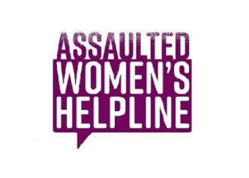In recent days two of our important supporters have advised us of their decision to boycott Toronto Public Libraries as a way to stand with the transgender community and to oppose hate speech and those who would enable its dissemination and have requested that AWHL move or cancel our event. Our sponsors conveyed that this was an extremely difficult decision given the important work the AWHL does each and every day. They have not taken this step lightly and have not withdrawn their sponsorship. However, they felt that they could not attend.

AWHL recognizes the important role our public institutions play in providing places of refuge, of offering quiet space for reflection and acceptance of our most marginalized communities and the need to protect these spaces. It is precisely because of our mandate to deliver the crisis line service to ALL women in Ontario specifically women with disAbilities, immigrant women, women of colour, lesbians, bi-sexual women, transgender women, persons who identify as women, non-binary persons, rural and northern women, women who are the marginalized and isolated, that we cannot cancel or move the gala.

Financially it would be impossible for an agency of our size to move the gala without severely impacting our ability to deliver services. When news of the controversial speaking engagement broke , the majority of over $30,000 in non-refundable contracts had been paid and several thousands in sponsor monies, ticket sales and donations received. Without a major benefactor to help us recover those costs and guarantee the expected $70,000 in fundraising from this event, AWHL would have no choice but to drastically cut services, potentially reducing our call volume from over 49,000 calls to less than 40,000 and impacting our outreach.

The Assaulted Women’s Helpline’s commitment to the LGTBQ community has steadfastly grown over our 34 plus years. Our counsellors receive training on issues specific to abuse experienced by the LGBTQ community whether from outside or within intimate partner relationships. Callers who identify as in LGBQ have increased by 50% in the past three years. We need to continue to offer the safe space provided by the Helpline. To do so, we need to rely on our fundraising efforts.

Our priority is to the many diverse women who need our services. AWHL remains committed to helping and working with callers with compassion and in the spirit of inclusion. We meet ALL individuals from where they are at with respect and without judgment.

AWHL stands with the LGBTQ community and supports safe spaces being created across Canada. We condemn any position that is anti-trans and does not recognize the fundamental human rights of all persons. For AWHL to continue the very important work we do 24/7, 365 days a year, we must move forward with this event.

The Assaulted Women’s Helpline will go ahead as planned with the 16th Annual Helpline Gala at the Bram and Bluma Appel Salon in the Toronto Reference Library on Friday, November 8th.

